Big sale

Limited Time Only

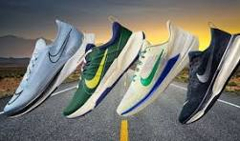

**BEST**

**PRODUCT**

STARTED

**SALE**

PRICE FROM $10

FREE COMFORT IN EVERY STEP, NJOY YOUR LYF

**ORDER NOW**

**Contact Us: 9989989123**

**goshoes.co.in**

O